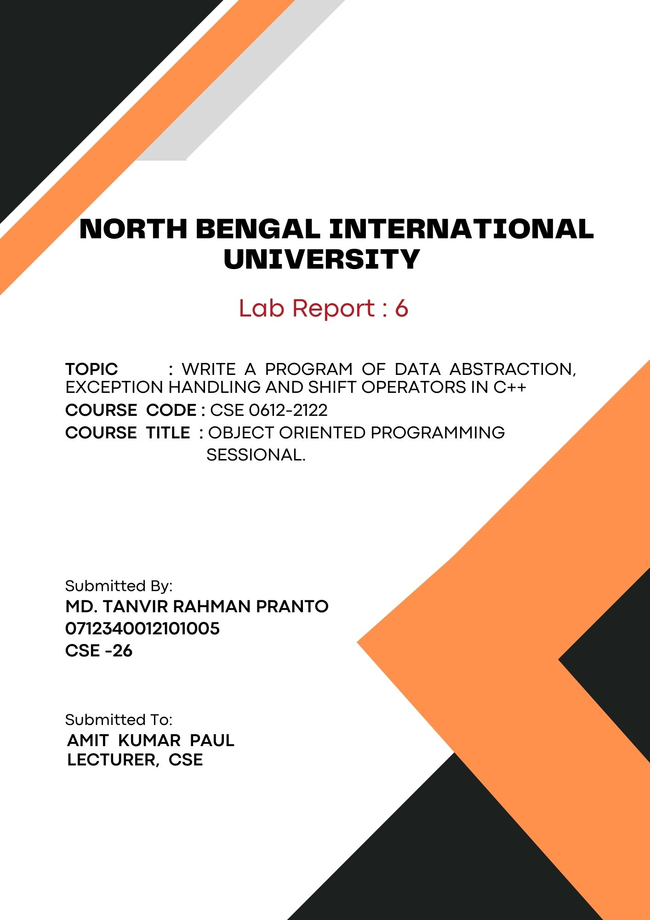
1

Write a program of Data Abstraction, Exception handling & Shift operators in C++:

# Data Abstraction:
Code:
#include <iostream>
using namespace std;

class Rectangle {
private:
double length;
double width;

public:
void setDimensions(double l, double w) {
length = l;
width = w;
}

double getArea() {
return length * width;
}
};

int main() {
Rectangle rect;
double length, width;

cout << "Enter the length of the rectangle: ";
cin >> length;
cout << "Enter the width of the rectangle: ";
cin >> width;

rect.setDimensions(length, width);

cout << "Area of the rectangle: " << rect.getArea() << endl;
return 0;
}

Output:
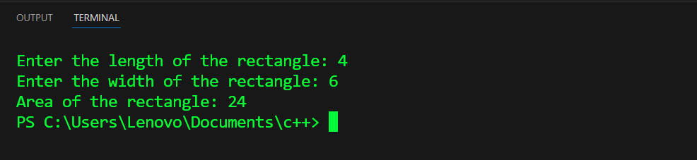

# Exception handling:
Code:
#include <iostream>
using namespace std;

double divide(double numerator, double denominator) {
if (denominator == 0) {
throw runtime_error("Division by zero error");
}
return numerator / denominator;
}

int main() {
double num, den;
cout << "Enter the numerator: ";
cin >> num;
cout << "Enter the denominator: ";
cin >> den;

try {
double result = divide(num, den);
cout << "Result: " << result << endl;
} catch (const runtime_error &e) {
cout << "Exception caught: " << e.what() << endl;
}

return 0;
}

Output:
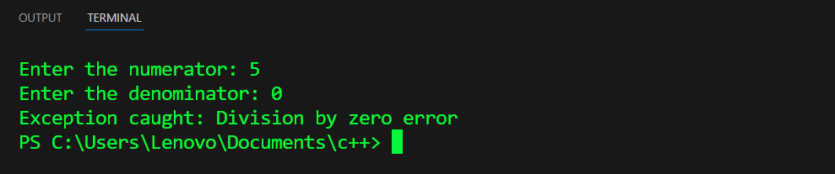

# Shift operators:
Code:
#include <iostream>
using namespace std;

int main() {
int num = 20; // Binary: 10100

int leftShift = num << 2;
cout << "Left Shift: " << num << " << 2 = " << leftShift << endl;

int rightShift = num >> 2;
cout << "Right Shift: " << num << " >> 2 = " << rightShift << endl;

return 0;
}

Output:
